**CHAROTAR UNIVERSITY OF SCIENCE & TECHNOLOGY**

**DEVANG PATEL INSTITUTE OF ADVANCE TECHNOLOGY & RESEARCH**

**Department of Computer Engineering**

**Subject Code and Name**: CE246 Database Management System

**Semester**: 4th

**Academic year**: 2022-23

**Practical - 1**

**Aim:** To Study DDL-create and DML-insert commands.

**Implementation:**

**From the above given tables perform the following queries:**

(1) Describe deposit, branch.

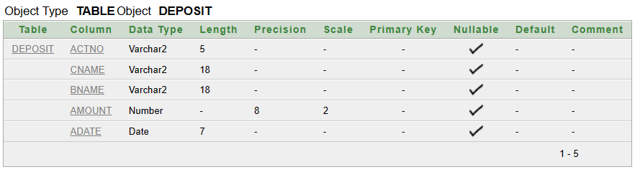 DESC DEPOSIT;

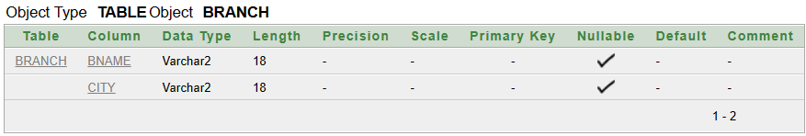 DESC BRANCH;

(2) Describe borrow, customers.

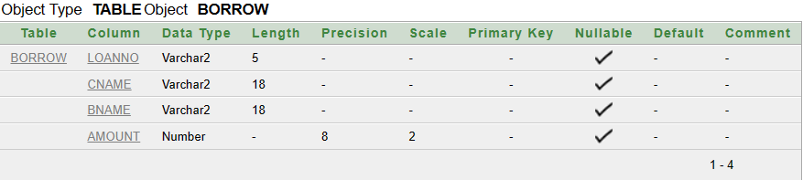 DESC BORROW;

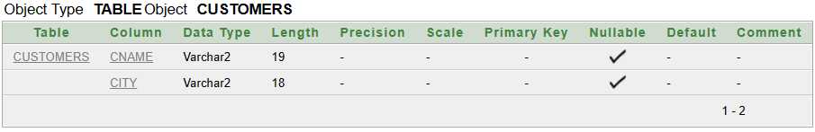 DESC CUSTOMERS;

(3) List all data from table DEPOSIT.

SELECT * FROM DEPOSIT;

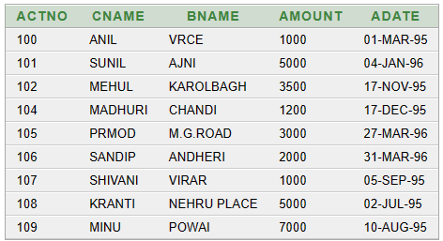

(4) List all data from table BORROW.

SELECT * FROM BORROW;

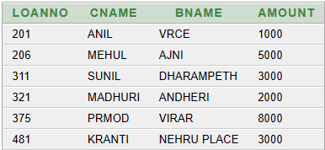

(5) List all data from table CUSTOMERS.

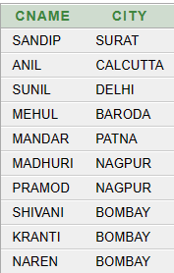SELECT * FROM CUSTOMERS;

(6) List all data from table BRANCH.

SELECT * FROM BRANCH;

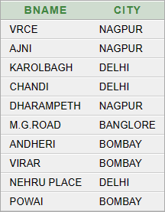

(7) Give account no and amount of depositors.

SELECT ACTNO,AMOUNT FROM DEPOSIT;

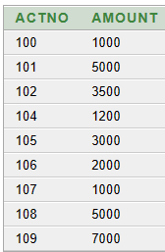

(8) Give name of depositors having amount greater than 4000.

SELECT CNAME FROM DEPOSIT WHERE AMOUNT>4000;

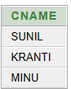

(9) Give name of customers who opened account after date '1-12-96'.

SELECT CNAME FROM DEPOSIT WHERE ADATE>'1-DEC-96';



(10) Give name of city where branch karolbagh is located.

SELECT CITY FROM BRANCH WHERE BNAME='KAROLBAGH';



(11) Give account no and amount of customer having account opened between date 1-12-96 and 1-6-96.

SELECT ACTNO,AMOUNT FROM DEPOSIT WHERE ADATE>'1-JUN-96' AND ADATE<'1-DEC-96';



(12) Give names of depositors having account at VRCE.

SELECT CNAME FROM DEPOSIT WHERE BNAME='VRCE';



**Remarks:** _______________________________________________________

**Marks:** ____________

**Signature:** ____________

**Practical - 2**

**Aim:** Create the JOB, EMPLOYEE, BORROW and DEPOSIT table and insert the data accordingly. To study various options of LIKE predicate.

**Implementation:**

**Remarks:** _______________________________________________________

**Marks:** ____________

**Signature:** ____________

**Practical - 1**

**Aim:** To Study DDL-create and DML-insert commands.

**Implementation:**

**Remarks:** _______________________________________________________

**Marks:** ____________

**Signature:** ____________